Module 6 – Large Kit: Thermodynamic Cycles
Thermodynamic cycles are used to model engines and heat pumps that we all use every day. A combustion engine (in a car) can be described accurately using this theory, as well as refrigerators, reverse-cycle heaters, jet engines and power generators. So thermodynamic cycles are essential to many aspects of our society and economy.

Outline
Primary learning outcomes for the module:
- Understand a range of thermodynamic cycles; heat engines, refrigeration cycles and a series of idealized thermodynamic cycles (e.g., Carnot cycle, Otto cycle, Diesel, and others)
- Be able to solve basic problems around thermodynamic cycles (e.g., efficiency, coefficient of performance, work, heat, change in internal energy, enthalpy, and entropy)
In completing a cycle, the change in all state functions becomes zero (but path functions can retain a finite value). So for example in a thermodynamic cycle, the change in internal energy (ΔE) becomes zero but work and heat are finite and further W_{Net} = -Q_{Net} ; heat added to the system can be converted into useful work (in the case of an engine).
Ultimately, we want to answer questions like, for a given amount of available heat, what is the maximum amount of useful work an engine can produce? If I fill up a car tank with fuel, what is the maximum distance it can drive?

6.1 Recap of your pre-existing knowledge (you may choose to skip to 6.2)
Student can come into Fun CE from a range of different backgrounds and so here we will just do a quick recap of the thermodynamics you probably already know.
If you already feel comfortable with this content, please skip ahead to 6.2. This sub-section (6.1) is not directly examinable, it’s just assumed background knowledge, so it will not be covered in detail in the course.
Before we can begin, we need to define a series of terms that will be used throughout the course (and throughout your degree) that are essential to describing thermodynamics:
- System vs surroundings
- The system is the object we want to study
- The surroundings are the rest of the universe (everything that is not the system)
- The boundary represents the interface between the system and surroundings
- If we were studying a train’s efficiency to convert coal into kilometres travelled, the train would be the system (coal as fuel is put in and work is taken out)
- By convention, a positive energy flow is always into the system (from the surroundings into the system). A negative energy flow implies the system is losing energy.
- Open system: Mass transfer may occur across the system boundary
- Closed system: Mass transfer may not occur across the system boundary
- Isolated system: No mass or heat transfer across the system boundary
- State: the conditions of the system (for example temperature, phase, enthalpy etc)
- Phase: How the system exists (solid, liquid or gas).
- Substance: Pure substance is made up of a uniform composition
- Homogeneous System: The properties are consistent throughout (e.g., density, phase, temperature)
- Heterogeneous System: Properties of the system vary throughout (e.g., if the system is a 2-phase mixture)
- Equilibrium: This has a range of meanings in thermodynamics but here we will use the definition that the system properties do not change with time (ie it is in a fixed, stable state).
- State Variable vs Path Variable
  - For a state variable, their value only depends on the final state of the system.
  - For a path variable, their value depends on how the system has moved from the initial state to the final state.

For example, a variable like work is a path variable: if I want to push a large block across a room, I could expend a small amount of energy by pushing it in a straight line from start to finish. Alternatively, I could push the block through a large detour, out of the room, down to the shops, then back again before I arrive at the final position and hence would expend much more energy to move the block from the initial to final position. As the amount of energy expended to move the block (the work) depends on the path to get the block from the initial to final position, we would say it is a path variable.

Alternatively, variables like temperature or density are not a function of how I move between states. A glass of water would be heated directly from 25ºC to 100ºC or it could be heated and cooled many times, before finally being heated to 100ºC. The final temperature is always still 100ºC (hence temperature is a state variable) however the amount of energy supplied to the system (the heat) would not be the same in both scenarios and hence heat is a path variable.

- Intensive property: The value of the property is independent of the amount of material present. Examples would be density or temperature. Whether we have 1kg or 2kg, the density of the material is the same.
- Extensive property: The property does depend on how much material is present. Examples would be volume or mass; 1kg and 2kg of a material will not have the same volume or the same mass.
- Process: When a system moves from one state to another.
- Cyclical process: In the next module we will look at a series of cyclical processes (where the system returns to its initial conditions), for example a heat engine which converts heat into work.
- Reversible process: The system can always be returned to its initial condition and there is no entropy change in the process.
- Adiabatic: No heat flow into the system during the process
- Isothermal: Constant temperature (isothermal process implies the temperature does not change)
- Isochoric (isometric): Constant volume (a process occurs but the total volume of the system does not change during the process)
- Isobaric: Constant pressure
- Isenthalpic: Constant enthalpy
- Isentropic: Constant entropy
- Heat: Transfer of energy related to a temperature difference
- Work: Transfer of energy involving mechanical motion across a system boundary

6.1.1 Temperature
We’re familiar with the concept of temperature (we can look up the daily temperature on our phone), but how would you describe what temperature is physically?
Descriptions of temperature tend to rely on implicit thermodynamics understanding:
A classical thermodynamic description: temperature is related to the thermal energy of the system and indicates the direction of heat flow; energy always flows from high to low (never spontaneously from low to high) to maximise an overall entropic condition. When 2 objects are at the same temperature, they are said to be at thermal equilibrium and there is no heat flow (this is a restatement of the zeroth law of thermodynamics).
A statistical thermodynamic description: temperature is related to the vibrational motion of atoms within matter. When atoms have no vibrational motion, this constitutes a fundamental lower limit on temperature (defined as absolute zero). Heat tends to flow from high concentration (high temperature) to low concentration (low temperature) because of the transfer of vibrational motion between adjacent atoms; atoms knock adjacent atoms. Given all atoms are equivalent, distributing the vibrational energy evenly between all atoms in the system represents the most probably final state for the system (thus why the thermal energy tends to distribute evenly throughout the system).

6.1.2 Zeroth Law of Thermodynamics
If object A is in thermal equilibrium with object B and object B is in thermal equilibrium with object C, then objects A and C must also be in thermal equilibrium.
This is a basic formal definition and doesn’t really allow us to show anything particularly interesting or solve useful problems.

6.1.3 Internal Energy
The internal energy represents the energy contained within the system. It does not include the kinetic energy of the system as a whole (if the whole system were moving) or the potential energy of the whole system (in an external field) because this would require a reference frame outside of the system. Internal energy is the energy contained within the system relative to the reference frame of the system (i.e., the system boundary).
Thinking about the statistical thermodynamic model, internal energy would represent things like the translational kinetic energy of individual molecules, vibrational and rotational states as well as the potential energy of intermolecular forces.

6.1.4 First Law of Thermodynamics
Sometimes called conservation of energy, it says the total energy of an isolated system must be constant. It is the law that prohibits perpetual motion machines. It is usually formulated to say that the change in internal energy of a closed system must equal the work supplied plus the heat supplied.
$$∆U=Q+W$$
Where ΔU: Change in internal energy of the system
Q: Heat flow into the system (flow of energy from a temperature gradient)
W: Work put into the system (flow of energy from motion)
Note that we refer to the change in internal energy and there is no absolute measure for internal energy itself (only relative to a datum).

Calculating work
Hopefully from previous physical based subjects, you know that work is the integral of force (F) with respect to distance (x).
$$W= -\int{Fdx}$$
Given that pressure (P) is force per unit area, and volume (V) is length x area, this can be rearranged to give:
$$W= -\int{PdV}$$
NB Note the minus sign to indicate work being done on the system. If the final volume is smaller than the initial volume the integral would be negative, but the system has gained energy (work has been done on it). The minus sign is required to set the sign of work to be consistent with our definition that positive energy implies the system has gained energy.

6.1.5 Enthalpy
So far in the notes we have invoked the concept of internal energy (in the first law of thermodynamics). The internal energy is the energy contained within the system boundary (how much energy the system has) but it doesn’t consider anything beyond the system boundary.
Now we introduce the concept of enthalpy, which is the internal energy of the system, plus some extra energy beyond the system boundary. This extra energy we include is the work required to create room for the system in the universe. Unless the system is created in a vacuum, there will be some energy required to displace the surrounding atmosphere, for the system to exist within (which would not be considered in the internal energy term). For this reason, enthalpy is sometimes called the thermodynamic potential of a system.
$$H=U+PV$$

Where,
- H: Enthalpy
- U: Internal Energy
- P: Pressure
- V: Volume
In Mass and Energy Balances, you used the concept of specific enthalpy widely (h, enthalpy per unit mass). As a reminder, you would have determined enthalpy 3 different ways: 1) By integrating specific heat values over a temperature range (dh = C_{P} dT) 2) By using averaged specific heat values and 3) By looking up enthalpy values in the steam tables (for water and steam).
We will use all this assumed knowledge in Fun CE.

6.1.6 Simple Mass and Energy Balances
The subject Mass and Energy Balances (CHEN20010) covers how to do mass and energy balances (unsurprisingly). You don’t need to know all the content from M&EB to do Fun CE, but it’s helpful to understand the very basics:
In chemical engineering problems, we usually assume mass in conserved, meaning that although matter can be transformed from one type of molecule into another (by chemical reaction) the mass can’t disappear or be destroyed. One kilogram of matter can change into other chemicals, but it’s still 1 kilogram. In 1905, Einstein showed this was not true (with the famous formula E = mc²) meaning mass can be transformed into energy, but we’ll just put this on hold for the moment. Ignoring nuclear reactions, we assume mass is conserved and it’s (almost) always true.
An energy balance is based on the first law of thermodynamics. Energy can be transformed into other forms, but the total amount of energy is always the same.
Using these 2 concepts, we can do a balance, to calculate the amount of mass coming out of a system (mass balance) or the temperature (or enthalpy) of mass when it leaves a system (from the energy balance).

Mass and Energy Balance Case Study: Heat Exchanger
In Fun CE we look at building and testing a heat exchanger in the practical. The purpose of a heat exchange is to move energy from one stream to another, but without mixing the steams. In the figure below, a hot stream (fluid 2) flows through a tube. Around the tube is a second larger tube (called the shell) that contains a cold fluid. If the tube is made of a highly conducting material (a metal like copper) then energy can flow from the hot steam (fluid 2) into the cooler stream (fluid 1). In this context, the energy moving from fluid 2 to fluid 1 is called heat. Fluid 1 will be warmer when it leaves the system and fluid 2 will be cooled.
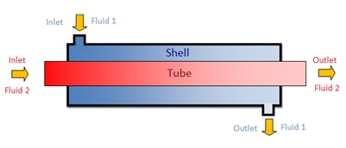

A basic mass and energy balance problem can be set up as below:
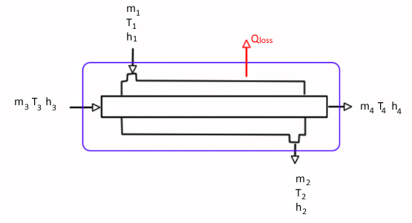
As the 2 fluids do not physically mix and only transfer heat, if we assume steady state (nothing is changing with time and so there is no accumulation of mass within the system) we can write:
m₁ = m₂
m₃ = m₄
The mass flow in through each tube must equal the mass flowrate out. We can also complete an energy balance by saying the energy lost by the hot stream must equal the energy gained by the cold stream, plus the energy lost to the environment (through the walls of the shell). In this case, the energy balance becomes:
Energy In - Energy Out + Accumulation = 0
Again, assuming steady state, accumulation = 0
m₁h₁ + m₃h₃ - m₂h₂ - m₄h₄ – Q_{loss} = 0
Just a reminder about the temperature profiles, T₃ > T₄ (the hot stream is being cooled); T₂ > T₁ (the cold stream is being heated). Substituting in the mass balance relationships and collecting common terms on a single side, we can write:
m₃(h₃ - h₄) = m₁ (h₂ – h₁) + Q_{loss}
The energy lost by the hot stream must be greater than the energy gained by the cold stream. In the diagram we have defined Q_{loss} as being out of the system, so if Q_{loss} is positive, it means the system is losing energy. If we drew the arrow the other day (going into the system) a Q would need to be negative for the system to lose energy. Direction is important in thermodynamic problems. In this module, we will use the convention that positive Q is always into the system (a positive heat flow implies the system is gaining energy).
We can now define an efficiency of the exchanger. 100% would imply all energy is transferred usefully from the hot stream to the cold. Less than 100% efficiency would imply some loss to the environment (the exchanger is not doing what it is designed to do).
$$h_{HEX}=\frac{m_{1}\left(h_{2}- h_{1}\right)}{m_{3}\left(h_{3}- h_{4}\right)} ×100 \\ h_{HEX}=1- \frac{Q_{loss}}{m_{3}\left(h_{3}- h_{4}\right)}$$

We also know that:
Q = U A ΔT_{LM}
Q: Heat flow between the hot and cold streams (usually expressed as joules/sec aka watts). This is not the same as Q_{loss}, it is the heat flow through the inner tube (between the tube and shell from hot to cold).
U: Heat transfer coefficient (a material property of the wall material, here the inner tube, as well as the fluid properties- you will learn to calculate this in Heat and Mass Transport Processes CHEN30005)
ΔT_{LM}: The log-mean temperature difference between the hot and cold stream sides. As the hot steam is getting colder and the cold stream is getting hotter, we need to take an average temperature difference between the 2 sides. You will learn about the origin of the log-mean temperature difference in Transport Processes.
So, the heat transferred between streams (Q) can be increased by:
- Increasing the temperature difference between hot and cold streams (ΔT_{LM}). A large temperature difference leads to a larger driving force for heat transfer. Touching something hot leads to a lot of energy being transferred into your hand (which scolds you fingers).
- Increasing the heat transfer area (A). If there is more area of contact between the hot and cold streams, the total amount of energy transferred will be greater. If the length of pipe of the HEX is very short, the stream temperatures will only change a little bit. If the length of pipe is very long, they will have more time to come to thermal equilibrium.
- Lowering the resistance to heat transfer (U). Typically, this means making the tube out of a highly conducting material. You can also lower U by agitating the fluid flow so no stagnant boundary layer of fluid forms near the wall to provide more heat transfer resistance.

6.1.7 Second Law of Thermodynamics
The second law of thermodynamics establishes the concept of entropy and then requires that for any isolated system the entropy always tends to a maximum. This has a number of important consequences: 1) the condition that heat flows from hot to cold (it never flows spontaneously from cold to hot) and 2) heat (a low-grade energy) cannot be completely converted into work (a high grade energy).
Entropy was developed as a concept first in the classical thermodynamic description when describing the isothermal step in a Carnot cycle (discussed in next module).
$$dS=\frac{dQ}{T}$$
Around a closed loop:
$$\oint{\frac{dQ}{T}=0}$$
So, entropy (S) is path independent and can be defined as a state function.

To illustrate how entropy tends to a maximum with a simple example:
Imagine a heat sink in contact with a hot reservoir and isolated from the universe. Initially an insulated divider separates the sink and reservoir to prevent heat flow. The divider insulation is then removed allowing heat to flow between the 2 systems. For energy to flow into the sink, the temperature of the sink must be less than the reservoir. So, imagine that T_{SINK} < T_{RES}.
From the first law of thermodynamics, the energy lost by the reservoir must equal the energy gained by the sink. δQ_{SINK} = -δQ_{RES}
Considering the sink and reservoir as a single isolated system (within the surrounding insulation):
The total change of heat of the system becomes:
δQ_{SYS} = δQ_{SINK} + δQ_{RES} = 0

Now consider the entropy change:
S_{SYS} = S_{SINK} + S_{RES}
= δQ_{SINK}/T_{SINK} + δQ_{RES}/T_{RES}
As δQ_{SINK} = -δQ_{RES} and T_{SINK} < T_{RES}, S_{SYS} must be > 0.
i.e., the entropy of the system as a whole must increase. This is the classical thermodynamic description of entropy; it is a parameter that is useful for describing heat flow, because it can be differentiated from energy (it came about from a description of the Carnot thermodynamic cycle, discussed in the next module). Although enthalpy change within the isolated system has remained zero, the entropy change has increased during the process of removing the thermal divider.

Entropy can also be described from a statistical thermodynamic perspective.
Imagine a box containing 8 atoms: 4 fixed on the left-hand side of the box and 4 fixed on the right-hand size.
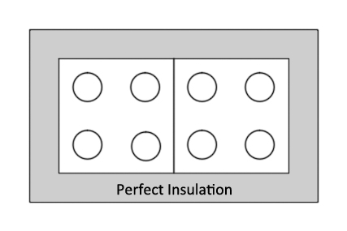
Imagine 4 quanta of energy are dropped into the box. One quanta of energy can associate with any one atom. The probability of all 4 units of energy going into the right-hand side of the box is very low (1/70). But the probability that 2 units of energy land on the right-hand side and 2 units land on the left-hand side is comparatively high (there are 36 configurations out of 70 total that give this outcome).
In essence there are many more ways for the energy to organize so that 2 atoms on the left and 2 on the right have energy (rather than all the energy on one side). If each configuration is equally probably and random, then the chance is it divided into 2 units of energy on the LHS and RHS is much more likely than it is dividing so that all energy is on a the RHS (36/70 vs 1/70).
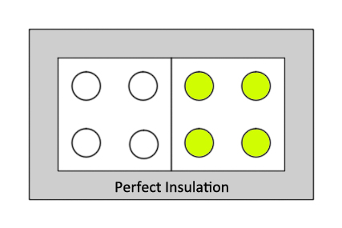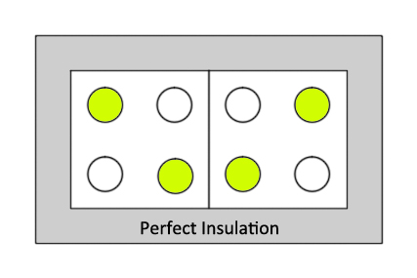
Imagine a thermal barrier in placed in the centre of the box. Energy in transferred from an external source into the right-hand side of the box. The thermal divider is then removed. If the energy is free to move between atoms, then over time it will organize itself to divide approximately evenly between the 2 halves. Why, because if the energy is free to move between atoms, then the probability of this outcome is much higher than all energy staying on one side of the box; there are more ways for the energy to configure itself. As the number of atoms increases and the amount of energy increases, the probability of dividing only increases.
This is why entropy is sometimes called a measure of the disorder of the system; the energy isolated in one half of the box represents an ordered state. This stored, concentrated energy can be used to extract useful work when it flows. Once the entropy of the system has been maximised (the energy quantas have been evenly distributed, the system has come to equilibrium, δQ/T inside the box is maximised) it can no longer extract work; our key resource is not energy, but an energy gradient. Energy evenly distributed throughout the universe has no use to us (this is sometimes called the entropic heat death of the universe and represents a theoretical point where the universe has reached its maximum entropic state and cannot sustain life and where no further work can be extracted).

6.2 Thermal Efficiency
Consider a steam engine. A furnace burns coal to release energy: some of this energy boils water to produce steam, which drives a piston/turbine to extract some useful work (e.g., for power generation in a coal-fired power plant, moving a locomotive in a steam train etc). However, some of the energy from the combustion of the coal cannot be recovered; it leaves in the flue gases as an exhaust. As this exhaust gas is not at absolute zero, we must consider this as lost energy that returns to the atmosphere and is not recovered for useful work.
A simplified way of thinking about the engine is shown below. The furnace represents a high temperature thermal source. Heat flows from this thermal source into the engine (Q_{H}) which extracts some useful work (W) but not all the energy from the heat source can be recovered and some of the heat is lost to a low temperature thermal sink (Q_{L}).
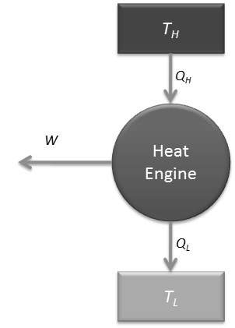
We will define the efficiency of the engine (η) as the amount of useful energy recovered (work, W) over the amount of heat supplied (Q_{H}) so that:
$$η=\frac{W}{Q_{H}}=\frac{Q_{H}-\left|Q_{L}\right|}{Q_{H}}=1-\frac{\left|Q_{L}\right|}{Q_{H}}$$
We could only obtain an efficiency of 100% if Q_{L} = 0 (i.e., the exhaust gas left the system at absolute zero, 0 K). We put the modulus around Q_{L} to emphasise that it has a positive value in the context of the calculation here (i.e., we do not expect an efficiency above 100% because heat is leaving the system).

6.3 Thermodynamic Processes
Simulating a real engine can often be so complex that it becomes impossible. To make problems solvable, we make a few simplifying assumptions. These assumptions are usually about the process taking place in each step in the cycle (usually that one parameter is constant), which comes to represent an optimal limit of the engine but are practically unattainable. This doesn’t make the thermodynamic simulation unrealistic or useless; it sets an upper limit on efficiency, for the best possible case and functions as a guide to how the performance of the engine will be affected when certain conditions are tuned.
We now want to derive the work, heat, change in internal energy and change in enthalpy for a range of processes:
- Isochoric
- Isobaric
- Isothermal
- Adiabatic
- Isenthalpic
- Isentropic
For an ideal gas, the internal energy and enthalpy can be expressed as:
dU = m C_{V} dT
dH = m C_{P} dT
Where C_{V} is the specific heat capacity at constant volume and C_{P} is the specific heat capacity at constant pressure. The derivation for the internal energy relationship is provided in Appendix A.
For an ideal monatomic gas, C_{V} and C_{P} are related to the degrees of freedom of the atoms and so C_{V} = 3/2R and C_{P} = 5/2R. The ratio of C_{P} / C_{V} is sometimes called the polytropic index and can be used to calculate the energy change in adiabatic systems.
Using these simplifications, we can complete the following derivations for ideal gases in the following processes:
Isochoric: Constant Volume
$$W= -\int{PdV}$$=0
ΔU = Q + W, so ΔU = Q = m C_{V} ΔT

Isobaric: Constant Pressure
$$W= -\int{PdV}$$
= - P ΔV
ΔH = ΔU + Δ(PV) = Q + W + VΔP + PΔV
Substituting in our solution for work.
ΔH = Q – PΔV + VΔP + PΔV
And as P is constant
ΔH = Q = m C_{P} ΔT

Isothermal: Constant Temperature
$$W= -\int{PdV}$$
Using the ideal gas law
PV = nRT
P = nRT/V
Substitute into the work
$$W= -\int{\frac{nRT}{V}dV}$$
W = - nRT ln (V₂/V₁)
Constant temperature, so ΔU = ΔH = 0
So Q = nRT ln (V₂/V₁)

Adiabatic: No heat flow (perfect insulation)
For adiabatic processes, we can make use of the polytropic relationship.
PV^{γ} = constant
Where γ is the polytropic index. The polytropic index is the ratio of the specific heat capacity at constant pressure over the specific heat capacity at constant volume, so for monatomic ideal gases, this is usually assumed to be 5/3. But the specific value of γ makes no difference to the derivation here.
$$W= -\int{PdV}$$PV^{γ} = constant (only for adiabatic processes)
So, C = PV^{γ} = P₁V₁^{γ} = P₂V₂^{γ}
$$W= -\int_{V_{1}}^{V_{2}}{\frac{C}{V^{γ}}dV} \\ =-C\left(\frac{{V_{2}}^{1-γ}-{V_{1}}^{1-γ}}{1-γ}\right)$$C can be P₁V₁^{γ} or P₂V₂^{γ} depending on which is more convenient because these are equal.
So the work simplifies to:
W = (P₂V₂ – P₁V₁) / (γ – 1)
Adiabatic, so Q = 0
So W = ΔU = m C_{V} ΔT

Isenthalpic: Constant Enthalpy
As the enthalpy is constant, for an ideal gas this implies a constant temperature.
ΔU = ΔH = 0
Q = -W = nRT ln (V₂/V₁)

A summary of all solutions to all the processes is shown below. You need to know how to derive all of these relationships (do not try to just memorize them).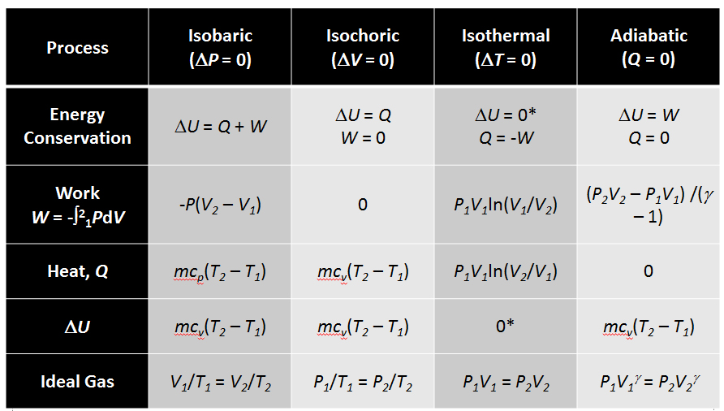

Worked Example 6.1:
One mol of an ideal monatomic gas undergoes the following reversible cycle in a frictionless cylinder:
- An Isothermal expansion
- An Isobaric compression
- An adiabatic compression
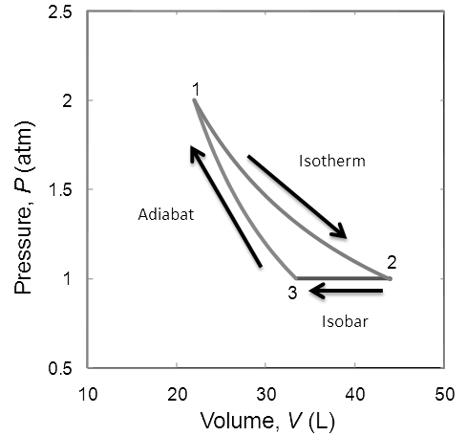

The conditions are:
Point 1: P₁ = 2 atm, V₁ = 22 L
Point 2 and Point 3: P₂ = P₃ = 1 atm
- Calculate the pressure, volume and temperature at each point in the cycle
- Calculate the change in enthalpy, internal energy, heat and work in each step
- Calculate the thermal efficiency of the engine
As the gas is ideal, we may assume that C_{P} of the gas = 5/2R and C_{V} = 3/2R

6.4 Types of Cycles

6.4.1 Heat Engine
A heat engine converts heat into mechanical work so on a P-V diagram a thermodynamic cycle for a heat engine would be sequenced in a clockwise direction; it has a positive net heat into the system and negative net work (the system does work on the environment).
Heat engines are essential to everyday life: internal combustion engines (petrol and diesel engines for cars) and external combustion engines (gas turbines and steam turbines to generate power).
We can conceptualize heat engines with the diagram below. Heat flowing from a hot source to a cold sink can be exploited to generate useful work. The heat engine diagram is set out next to a schematic for a steam turbine, to illustrate how the engine works.
A furnace (coal fired, gas fired, nuclear powered) generates heat which is used to boil steam (Q_{H}). As this steam builds up pressure and can be used to drive a turbine (to generate useful shaft work, W_{S}). The low-pressure steam leaves the turbine and must be recompressed so it can be sent back to the boiler. To do this, the steam is condensed, but in doing so it loses some energy to the environment (Q_{L}). The now liquid water is pumped back up to the design pressure of the boiler (using some of the shaft work from the turbine) and recycled to be boiled again.
Thinking about an energy balance around the steam engine, shows that the only energy crossing the system boundary is Q_{H}, Q_{L} and W_{S} such that Q_{H} = Q_{L} + W_{S}.

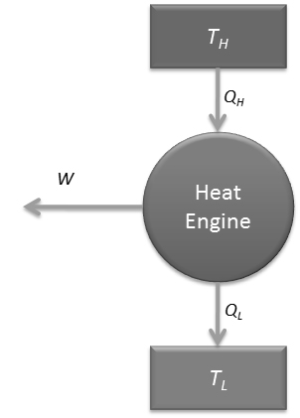

6.4.2 Heat Pump
In essence, a heat pump works in the opposite way to a heat engine. It converts shaft work into heat flow, or more specifically, by taking in shaft work we can pump energy from cold to hot (where it would usually flow spontaneously from hot to cold). On a P-V diagram, this manifests as a thermodynamic cycle in a counter-clockwise direction; the net work is positive and net heat flow is negative into the system. The standard example of a heat pump is your refrigerator.
To help illustrate, a diagram of a heat pump is laid out next to a schematic for a refrigerator below. Beginning at point 1 in the refrigerator schematic, a low boiling point liquid held at low pressure is passed through an evaporator. The liquid evaporates, pulling heat from the cooling the heat source (Q_{L}) and dropping its temperature (this would be the inside of your refrigerator).
A compressor is then used to increase the pressure of the low temperature – low pressure saturated vapour from the evaporator. This compressor needs shaft work to do the compression (W_{C}), typically provided by an electric motor. As the pressure increases, the gas heats, and the boiling point rises, which results in a super-heated state for the vapour after the compressor. So, when it passes to the condenser, its temperature is now well above the ambient air temperature. Energy can be pulled from the high temperature super-heated vapour (Q_{H}) first cooling it to its boiling point and then condensing it. The condensed vapour is then passed through an expansion valve, where its pressure drops (which also drops its boiling point). The vapour will partially flash and cool and so it can be returned to the evaporator at low temperature again.
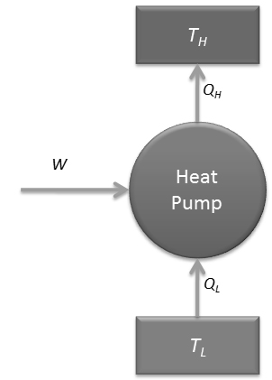

Initially a heat pump may appear to violate the second law of thermodynamics; energy is being pumped from cold to hot, essentially creating more order. But it’s important to remember that the shaft work used to drive the heat flow must come from somewhere; this shaft work creates a greater entropy somewhere else in the universe. So, the net entropy of the universe still increases and the second law of thermodynamics has not been violated.

6.5 Model Cycles
There are a range of theoretical models that can be used to describe heat engines and heat pumps. These consist of at least 3 (usually 4) thermodynamic processes. There are not real engine cycles, but rather theoretical cycles to describe idealized (maximally efficient) operations.

6.5.1 Carnot Cycle
In a Carnot cycle, there are 2 temperature reservoirs (at temperatures T_{H} and T_{C} respectively). They are considered to be sufficiently large that the temperature of the reservoirs is not affected by the process of each cycle.
The cycle itself consists of 4 processes:
- Isothermal expansion: Heat added to system, Work extracted from system
Heat is added to the system, so it expands, but the heat is added sufficiently slowly and incrementally so that there is no localized heating. The system remains at constant temperature and in thermal equilibrium with the surroundings as the system expands.
- Adiabatic expansion: Work extracted from system
The system is insulated from the surroundings and continues to expand, but now its temperature drops (as no heat flows into the system during expansion).
- Isothermal compression: Heat extracted from system; Work added to the system
The system is placed in surroundings at the same temperature as this new low temperature. The insulation is removed, and the system is slowly compressed. The compression is sufficiently slow and incremental so that any localised heating keeps the system in thermal equilibrium with the surroundings.
- Adiabatic compression: Work added to the system
The system is again thermally insulated and compressed (adiabatically). As the system is compressed, its temperature increases from the low temperature (thermal sink) back to the higher temperature (thermal reservoir).
As the 4 steps all represent idealized processes, the Carnot cycle is used to represent the highest possible thermal efficiency for an engine (a theoretical upper limit on engine performance).
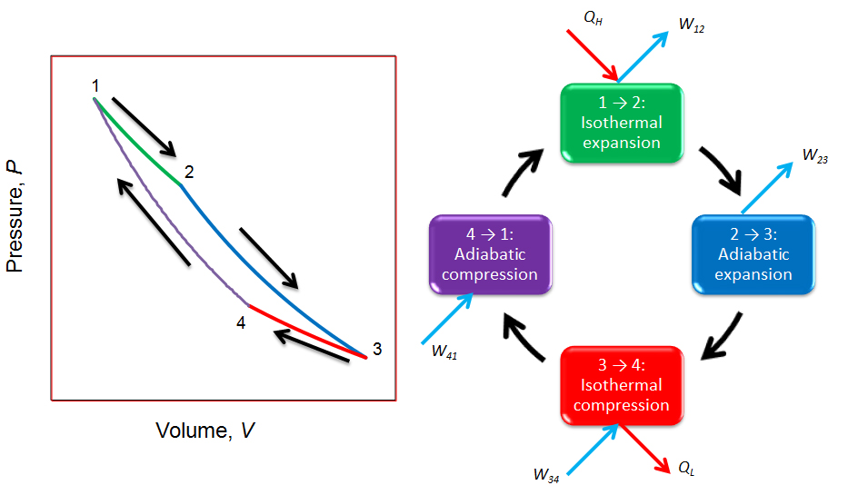
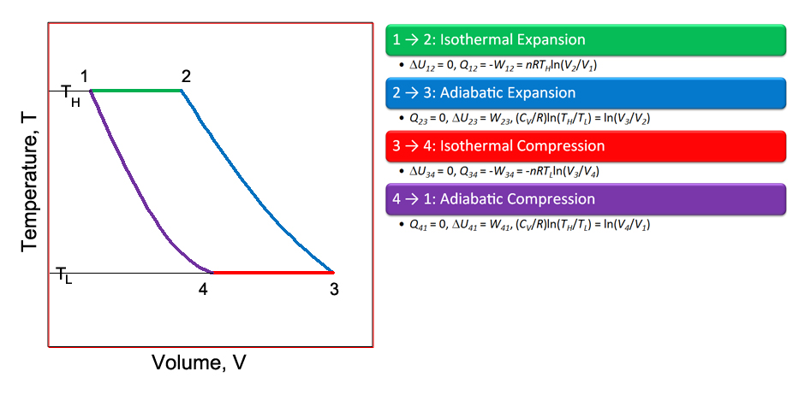

The cycle is reversible (no entropy change, maximum efficiency) and so the entropy lost by hot reservoir balances the entropy gained by the cold reservoir. The amount of heat extracted from the hot reservoir (Q_{H}) and deposited in the cold reservoir (Q_{L}) can therefore be written as:
Q_{H} = T_{H}ΔS
Q_{L} = T_{L}ΔS
And the difference between Q_{H} and Q_{L} is written as the work (W_{S})
W_{S} = (T_{H} – T_{L}) ΔS

Carnot Cycle Efficiency
The Carnot cycle represents the maximum possible efficiency for an engine given a particular temperature limit between the heat source and heat sink (think of the temperature of a boiler vs the exhaust temperature).
$$η=1-\frac{\left|Q_{L}\right|}{Q_{H}}$$
From the figure above, heat is only added or removed in 2 steps in the Carnot cycle (in the isothermal expansion and isothermal compression; by definition no heat is added/removed in the adiabatic steps).
We previously derived the heat flow during an isothermal process to be:
Q = nRT ln (V₂/V₁)
So Q_{H} = nRT_{H} ln (V₂/V₁) (V₂>V₁ so Q_{H} is positive as expected)
and Q_{L} = nRT_{L} ln (V₄/V₃) (V₄<V₃ so Q_{L} is negative as expected)
|Q_{L}| = nRT_{L} ln (V₃/V₄) (so it has a positive sign)
For the adiabatic step 4→1, we have previously shown that:
P₁V₁^{γ} = P₄V₄^{γ}
Using the ideal gas law, PV=nRT
V₁^{γ-1} nRT_{H} = V₄^{γ-1} nRT_{L}
T_{L}/T_{H} = V₁^{γ-1}/V₄^{γ-1}
Similarly for the adiabatic step 2→3:
P₂V₂^{γ} = P₃V₃^{γ}
Substituting in the ideal gas law
T_{L}/T_{H} = (V₂/V₃)^{γ-1}
So T_{L}/T_{H} = (V₁/V₄) ^{γ-1} = (V₂/V₃)^{γ-1}
So V₁/V₄ = V₂/V₃
Rearrange: V₂/V₁ = V₃/V₄
Substituting into the efficiency calculation:
η = 1 - nRT_{L} ln (V₃/V₄)/ nRT_{H} ln (V₂/V₁)
ln (V₃/V₄) = ln (V₂/V₁)
$$η=1- \frac{T_{L}}{T_{H}}$$
For a Carnot cycle, the ratio of temperatures (between heat source and heat sink) is related to the ratio of heat flows and the efficiency of the cycle.
To maximise the efficiency of the Carnot cycle, we want to minimise the ratio of T_{L}/T_{H}; this means lowering the temperature of the sink (reducing heat losses) or raising the temperature of the heat source (to minimise the percentage of heat lost to the thermal sink).
The Carnot cycle (the theoretical maximum efficiency engine) can only have 100% efficiency when the temperature of the heat sink is 0 K (i.e., absolute zero).

Worked Example 6.2
Determine the maximum amount of work that may be extracted from a heat engine with a heat source at a temperature of 1500ºC which provides 500 MW of power, given the heat sink is at a temperature of 20ºC.
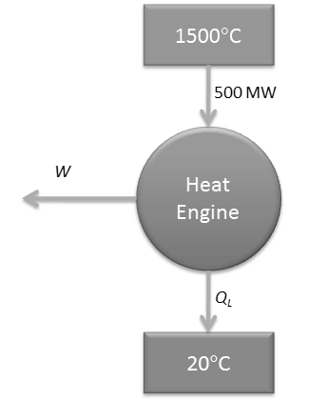

Worked Example 6.3
Determine the heat input into a Carnot engine that operates between temperature limits of 350ºC and 25ºC and produces 100 kJ of work output.
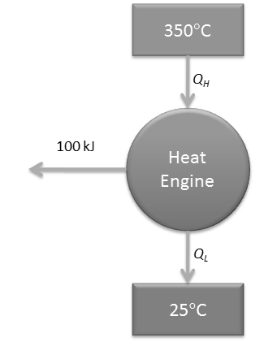

6.5.2 Reverse Carnot Cycle
So far, we have spoken about the Carnot cycle as a model for a heat engine. If we reverse the direction of thermodynamic processes in the cycle (on a P-V diagram this now moves in a counter-clockwise direction) we can consider the Carnot cycle as a model for a heat pump: Net work is added to the system and net heat is taken out of the system; the heat source is the low temperature, and the heat sink is now at the high temperature.
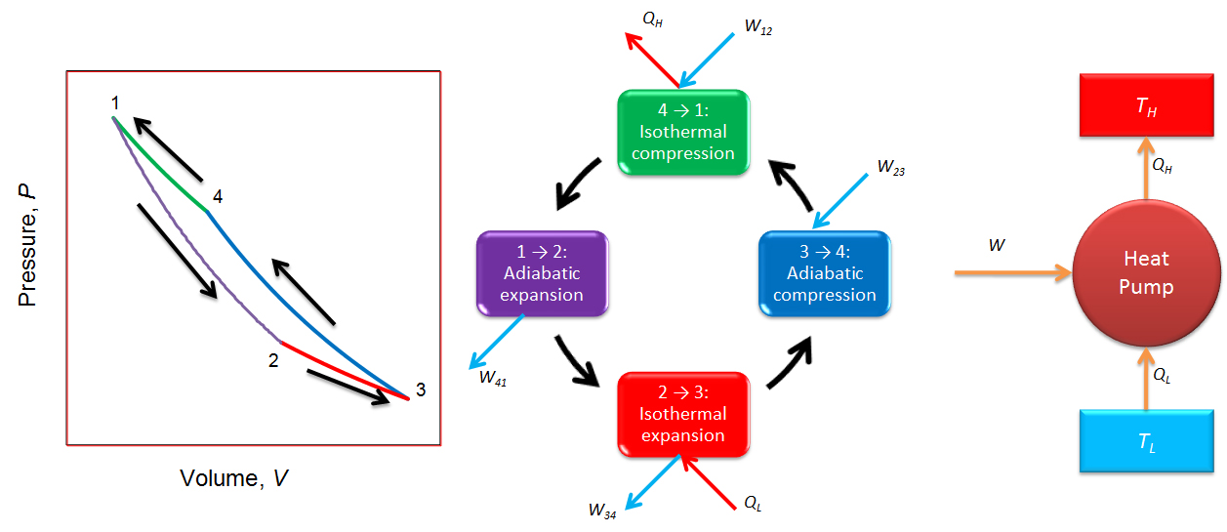
Rather than thinking about the efficiency of a reverse Carnot cycle, we introduce the concept of coefficient of performance (COP). Like the efficiency, the COP is still defined as ‘what we get out’ vs ‘what we pay for it’ but here the benefit is the cooling duty at the low temperature source and the cost is the work supplied to drive the heat transfer from cold to hot.
$$COP=\frac{Q_{L}}{W}$$W = |Q_{H}| - Q_{L} (we add the modulus to Q_{H} to denote it as positive here)
COP = Q_{L}/(|Q_{H}| – Q_{L})
As before, Q_{L}/|Q_{H}| = T_{L}/T_{H}
$$COP=\frac{T_{L}}{T_{H}{-T}_{L}}$$
Note that because of the definition of coefficient of performance, it can be above 100% (unlike the efficiency calculation)

6.5.3 Otto Cycle
The Otto cycle is a thermodynamic cycle typically used to model a spark ignition engine (for example a 4-stroke petrol engine in a car).
The Otto cycle consists of the following steps:
1→2 Isochoric heat addition: This is intended to represent the ignition of the fuel-air mixture in the engine cylinder. The cylinder is at its most compressed position and a spark plug ignites the fuel-air mix. Before the piston has time to physically move, the pressure dramatically increases due to rapid combustion. This step takes place almost instantaneously (a very short time scale).
2→3 Adiabatic expansion: This is often called the power stroke. It is intended to represent the expansion of the cylinder as it now has time to move from the higher pressure generated after ignition of the fuel. It takes place over a longer time scale than step 1→2.
3→4 Isochoric heat removal: Heat is rejected from the exhaust gases while the piston is at its highest position (commonly called bottom dead centre, because of the distance from the crank shaft)
4→1 Adiabatic compression: New fuel is injected into the cylinder and it is compressed from bottom dead centre to top dead centre position, ready for ignition again, so the cycle is completed.
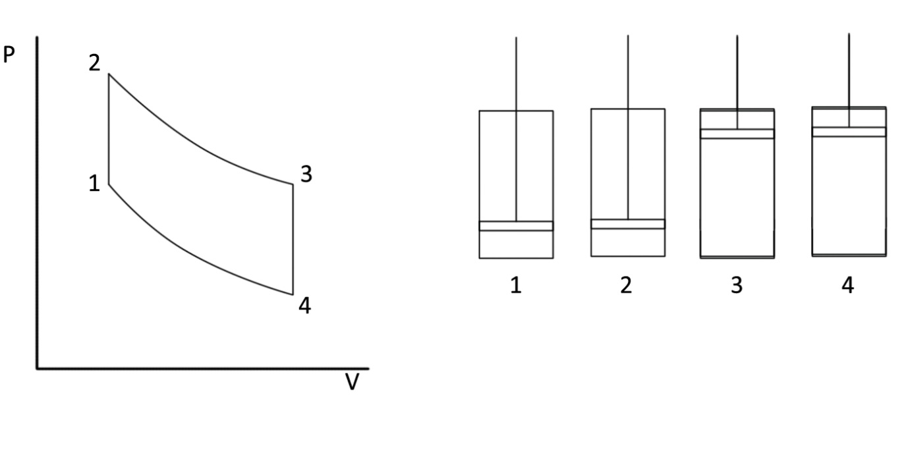
From the known thermodynamic relationships derived earlier, we can determine the efficiency of the Otto cycle (as we did for the Carnot cycle) for an ideal gas. This derivation is left as an exercise in one of the tutes but should yield the result:
$$η_{Otto}=1-\frac{1}{r^{γ-1}}$$
Where γ is the polytropic index as used before (C_{P}/C_{V}) and r is the compression ratio, which represents the highest piston volume (bottom dead centre) over the lowest piston volume (top dead centre).
$$r=\frac{V_{4}}{V_{1}}$$
To conceive of this another way, imagine a piston with a spark plug at the bottom. The spark plug can be turned on manually at any time to ignite the fuel. Imagine the piston is charged with fuel. The plunger is manually pushed down towards the bottom of the cylinder, and then the fuel is ignited with the spark plug. The piston will push against atmospheric resistance for a long stroke and hence will do a lot of work. Imagine the experiment is repeated but that the plunger is only pushed halfway down the cylinder. When the fuel is ignited, the system will do less work because the length of the stroke will be shorter (for the same input of fuel). So, the compression ratio (how far down the plunger can be pushed before ignition) is essential to the overall efficiency of the engine.
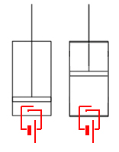

Worked Example 6.4
A petrol engine can be modelled as an Otto cycle. The maximum pressure in the cycle is 30 atm and the minimum pressure in the cycle is 1 atm. The cylinder has a maximum volume of 1L and a compression ratio of 10. Assuming a polytropic index of 1.2, calculate the net work in the cycle and heat into the system (Q_{H})

6.5.4 Diesel Cycle
The Diesel cycle is an idealized thermodynamic cycle used to model a diesel engine. The diesel engine is named after Rudolph Diesel who developed the theory and patent for the engine in the early 1890s. The first Diesel engine was not built until 1897. In the history of science, this is an example where theory preceded invention; Diesel understood that the fuel efficiency in a petrol engine was limited by its compression ratio and built an engine to pass this limit.
Unlike a conventional petrol engine, a diesel engine has no spark plug (a spark plug is connected to the car battery and provides a spark ignition for the fuel). Instead, the fuel-air mixture is compressed to a point where the temperature increases to the auto-ignition temperature of the fuel. This means the fuel-air mixture needs to be compressed to a smaller volume (greater compression ratio) which results in higher overall efficiency.
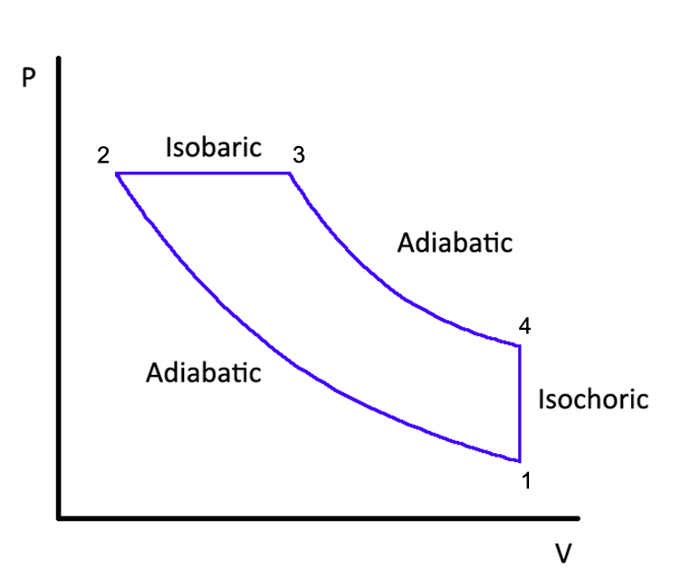
The cycle is similar to an Otto cycle, but steps 2→3 are an isobaric expansion (not isochoric).
1→2 Adiabatic (isentropic) compression of the fuel; work is done by the piston compressing the fuel-air mixture. The system is compressed further than in an Otto cycle, to the auto-ignition temperature of the fuel.
2→3 Constant pressure heating from the combustion of the fuel
3→4 Adiabatic expansion of the working fluid to push the piston out and produce usable work
4→1 Isochoric cooling by venting the exhaust gases from the piston
The efficiency of the Diesel engine may be derived to give:
$$η_{Diesel}=1-\frac{1}{r^{γ-1}}\left(\frac{α^{γ}-1}{γ\left(α-1\right)}\right)$$
Where r: compression ratio (V₁/V₂)
α: Cutoff Ratio (V₃/V₂)
γ: Polytropic index

6.5.5 Comparing Otto Cycle and Diesel Cycle
The Otto and Diesel cycles are very similar; they would be identical except for the isobaric step after fuel ignition in the diesel cycle. The diesel cycle usually produces more fuel-efficient engines; the reasoning can be seen when overlaying the thermodynamic cycles below.
Imagine 2 cylinders are made with equal maximum volume; one for an Otto cycle and one for a Diesel cycle. The same amount of fuel-air mix is put into both cylinders. As the Diesel cycle compresses the cylinder to a smaller final volume (to reach the auto-ignition temperature of the fuel) it extracts more work in each cycle.
This can be reasoned graphically as well. The area enclosed by the cycle on the P-V diagram represent the work done per cycle. When overlaying the 2 cycles, for the same total cylinder volume and the same maximum pressure in the cycle, the Diesel cycle encloses a larger area than the Otto cycle, because it can compress the plunger to a smaller volume.
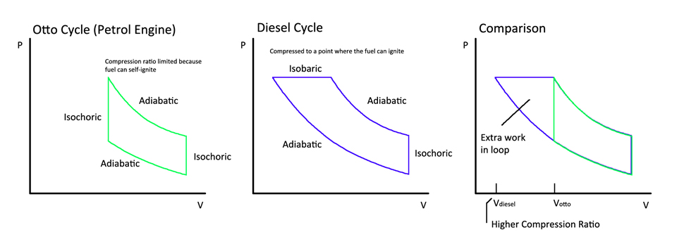

6.6 Other Thermodynamic Cycles
A summary of other cycles you may encounter.
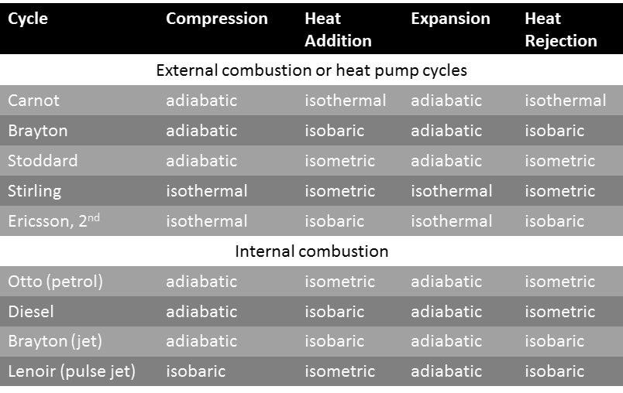

Module 6 Summary

Key Concepts:
- Basic thermodynamics
  - Laws of thermodynamics
  - Thermal efficiency
  - Thermodynamic cycle stages (isochoric, isobaric, isothermal, adiabatic)
- Thermodynamic cycles
  - Heat engine/ pump
  - Carnot/ Reverse Carnot
  - Otto
  - Diesel
  - Other cycles

Key Skills:
- Calculate thermodynamic efficiency, work, and power for a cycle
- Derive expression for efficiency, work and power based on cycle stages (isochoric, isobaric, isothermal, adiabatic)

